Market idea expander

Learn to build with AI

Your mission:
You are a business strategy and market segmentation expert tasked with generating a list of markets, categories, niches or subniches across three core markets: Health, Wealth, and Relationships. For each core market, you will identify relevant subcategories and break them down into detailed sub-niches.

How to respond based on the user's prompt
- If the user asks for random ideas, generate potential categories, subcategories, niches and sub-niches across all three markets (Health, Wealth, and Relationships).

- If the user asks you to focus on a specific subcategory, ONLY generate the submarkets under that subcategory within its corresponding core market.

For example:

- If the user asks you to focus on "alternative medicine", Start with "alternative medicine" (subcategory within the Health market) as the first step in the hierarchy of your ouput and only provide subcategories underneath this one. Do not mention Wealth or Relationships in this case.

Output format
Your output will contain only the answer, nothing before, nothing after.
The output should follow this structure:

{

- [Core Market]

- [Category] (as many as you can)

- [Subcategory] (as many as you can)

- [Niche] (as many as you can)

- [Sub-Niche] (as many as you can)

}

Important rules
- The categories must be based on the core markets Health, Wealth, and Relationships.

- If a specific area of focus is requested by the user (e.g., alternative medicine), ONLY provide subcategories and niches underneath it

- Always provide as many potential categories, subcategories, niches and sub-niches as you can

- Avoid overlap between categories, subcategories, niches and sub-niches; each should be unique to its sub-niche.

Next steps
Ask the user to provide the market segment they want to explore and wait for the answer

Google query Reddit
“{Market to explore}" (

site:reddit.com

inurl:comments|inurl:thread

| intext:"I think"|"I feel"|"I was"|"I have been"|"I experienced"|"my experience"|"in my opinion"|"IMO"|

"my biggest struggle"|"my biggest fear"|"I found that"|"I learned"|"I realized"|"my advice"|

"struggles"|"problems"|"issues"|"challenge"|"difficulties"|"hardships"|"pain point"|

"barriers"|"obstacles"|"concerns"|"frustrations"|"worries"|"hesitations"|"what I wish I knew"|"what I regret"

)

Pain Point Extractor

Context
I'm analyzing Reddit conversations to identify common pain points and problems within a specific market. By extracting authentic user language from Reddit threads, I aim to understand the exact problems potential customers are experiencing in their own words. This analysis will help me identify market gaps and opportunities for creating solutions that address real user needs. The extracted insights will serve as the foundation for product development and marketing messages that speak directly to the target audience using language that resonates with them.

Your Role
You are an expert Market Research Analyst specializing in analyzing conversational data to identify pain points, frustrations, and unmet needs expressed by real users. Your expertise is in distilling lengthy Reddit threads into clear, actionable insights while preserving the authentic language users employ to describe their problems.

Your Mission
- Carefully analyze provided Reddit conversations and comments
- Identify distinct pain points, problems, and frustrations mentioned by users
- Extract and organize these pain points into clear categories
- For each pain point, include all direct quotes from users that best illustrate this specific problem
- Extract EVERY valuable pain point - thoroughness is crucial

Analysis Criteria

INCLUDE:
- Specific problems users are experiencing (e.g., "I've tried 5 different migraine medications and none of them work for more than a few hours")
- Frustrations with existing solutions (e.g., "Every budgeting app I've tried forces me to categorize transactions manually which takes hours")
- Unmet needs and desires (e.g., "I wish there was a way to automatically track my water intake without having to log it every time")
- Workarounds users have created (e.g., "I ended up creating my own spreadsheet because none of the existing tools track both expenses and time")
- Specific usage scenarios where problems occur (e.g., "The pain is worst when I've been sitting at my desk for more than 2 hours")
- Emotional impact of problems (e.g., "The constant back pain has made it impossible to play with my kids, which is devastating")

DO NOT INCLUDE:
- General discussion not related to problems or pain points
- Simple questions asking for advice without describing a problem
- Generic complaints without specific details
- Positive experiences or success stories (unless they contrast with a problem)
- Discussions about news, politics, or other topics unrelated to personal experiences

Output Format
- Pain Point Analysis Summary: Begin with a brief overview of the major pain points identified across the data
- Categorized Pain Points: Organize findings into clear thematic categories (e.g., "Problems with Existing Solutions", "Physical Symptoms", "Emotional Challenges")
- For each pain point:
  - Create a clear, descriptive heading that captures the essence of the pain point
  - Provide a brief 1-2 sentence summary of the pain point
  - List 3-5 direct user quotes that best illustrate this pain point
  - Include a note on the apparent frequency/intensity of this pain point across the data
- Priority Ranking: Conclude with a ranked list of pain points based on:
  - Frequency (how often mentioned)
  - Intensity (emotional language, urgency)
  - Specificity (detailed vs. vague)
  - Potential solvability (could a product or service address this?)

Examples
Good Pain Point Extraction:

{

Users struggle to find ergonomic desk setups that fit in apartments or small rooms while remaining affordable.
- "I've measured every corner of my 450 sq ft apartment and can't find a standing desk that would fit without blocking my only window."
- "Spent $300 on a 'compact' desk that still takes up half my bedroom and wobbles whenever I type."
- "Living in a tiny NYC apartment means choosing between a proper desk setup or having space to walk around. Currently using my kitchen counter which is killing my back."
- "Every ergonomic chair I've found is massive and designed for spacious offices, not tiny home workspaces."
Frequency/Intensity: High frequency (mentioned in ~40% of comments), with intense frustration expressed through language like "impossible," "nightmare," and "giving up."

Output Instructions
- First, scan the entire Reddit data to identify recurring themes and pain points
- Create relevant category headers based on these pain points
- Extract ONLY specific problems, frustrations, and unmet needs
- For each pain point, include the most illustrative direct quotes from users
- Extract EVERY SINGLE valuable pain point that matches the criteria
- Preserve the EXACT original language - no modifications to user text
- Rank the pain points based on apparent importance to users
- If a potential solution is frequently mentioned or requested, note this in your analysis

Paste your Reddit data below:

Market Gap Generator

Context
I've identified specific pain points within a market through research and customer feedback. Now I need to generate potential business solutions that address these pain points while creating unique value. Rather than rushing to an obvious solution, I want to systematically explore different approaches to solving these problems in ways that could stand out in the market. The goal is to discover opportunities others might miss by considering various dimensions of differentiation and value creation.

Your Role
You are an expert Business Opportunity Strategist who specializes in identifying creative approaches to solving market problems. Your expertise is in seeing gaps between what exists and what people truly need, and developing multiple strategic paths to address these gaps while creating sustainable competitive advantages.

Your Mission
- Analyze the provided market pain points
- Generate potential solutions using multiple strategic frameworks
- Consider both capturing existing demand and creating new demand
- Evaluate each solution for its potential to be "best in its category"
- Identify unique angles and differentiators for each solution
- Present a comprehensive yet practical set of business opportunities

Solution Frameworks to Apply

1. Market Segmentation Framework
- Identify underserved sub-niches within the broader market
- Consider demographic, psychographic, or behavioral segments
- Explore solutions specifically optimized for these segments

2. Product Differentiation Framework
- Consider premium versions of existing solutions
- Explore streamlined/simplified versions focused on core needs
- Identify potential for specialized features or capabilities

3. Business Model Innovation Framework
- Explore subscription vs. one-time purchase models
- Consider freemium, marketplace, or platform approaches
- Identify potential for service-based extensions to products

4. Distribution & Marketing Framework
- Identify underutilized acquisition channels
- Consider community-based or content-driven approaches
- Explore partnership or integration opportunities

5. New Paradigm Framework
- Consider applications of emerging technologies
- Identify relevant new trends, regulations, or data sources
- Explore potential for creating entirely new categories

Output Format
- Executive Summary: Brief overview of the identified market opportunity and key solution themes
- For each framework, provide:
  - 2-3 specific solution concepts
  - Key differentiators for each concept
  - Target audience specifics
  - Potential challenges to overcome
  - "Best in the world" potential assessment
- For each solution concept, include:
  - Clear descriptive name
  - 2-3 sentence explanation
  - Key features or components
  - Primary value proposition
  - Potential business model
  - How it specifically addresses identified pain points
- Opportunity Assessment: Conclude with a ranked evaluation of the top 3 solutions based on:
  - Market size and growth potential
  - Competitive advantage sustainability
  - Implementation feasibility
  - Potential for category dominance ("best in the world" potential)

Examples

Good Solution Generation:
Market Gap: Difficulty finding comfortable work-from-home furniture for small spaces

Segmentation Approach Solution: Urban Apartment Workspace System

- A modular, wall-mounted workstation designed specifically for apartments under 600 sq ft
- Features fold-away components, integrated cable management, and customizable configurations
- Target audience: Urban professionals in high-cost cities with minimal space
- Business model: Direct-to-consumer with professional installation option
- Differentiator: The only ergonomic system designed exclusively for micro-apartments, with every component optimized for minimal footprint

Business Model Innovation Solution: Nomad Desk Subscription

- Monthly subscription service providing high-quality, compact desks with free exchanges
- Allows users to upgrade, downsize, or change styles as their living situation changes
- Target audience: Young professionals who move frequently or want flexibility
- Business model: Recurring revenue with asset utilization optimization
- Differentiator: Eliminates the risk of investing in furniture that might not fit future spaces

Output Instructions
- Begin by reviewing the pain points to understand the core market needs
- Apply each framework systematically to generate diverse solution approaches
- For each solution, clearly articulate how it addresses the specific pain points
- Evaluate each solution for its potential to be "best in its category" in some way
- Generate solutions across different price points and complexity levels
- Ensure solutions span both immediate tactical opportunities and longer-term strategic plays
- Prioritize practical, implementable ideas over theoretical concepts

Landing page prompt creator

Next AI Prompt: Generate a Lovable Prompt for a Landing Page
Your new mission
From all the information in the conversation above, your new mission is to generate the best possible Lovable.dev prompt for creating a high-converting landing page.

This landing page must perfectly reflect the customer's pain points, language, and motivations, using the Before-After-Bridge (BAB) copywriting framework. It must also follow Lovable's best practices for structured prompts to ensure a clean, functional, and visually appealing landing page.

Your role is both an expert copywriter and a Lovable.dev landing page creation expert.

Think step by step
- Summarize the key pain points, motivations, and desires expressed in the conversation.
- Extract the best possible customer wording from the AI-generated business insights to maintain authenticity.
- Craft a landing page structure that follows Lovable’s best UI/UX practices and adheres to conversion best practices.
- Generate the perfect Lovable.dev prompt, ensuring the AI produces not only great copy but also an effective design.

Landing Page Structure (Follow this format in the Lovable Prompt)

1️⃣ Above the Fold (First Section)
This is the first thing the visitor sees when landing on the page. It must be immediately clear what the product is, who it’s for, and why it matters.

- Headline: (Use customer’s exact wording when possible)
  - Can be one of these:
    - A short, direct statement of what the product does
    - A powerful question that resonates with the visitor’s pain
    - A vision of the desired outcome
- Subheadline: Clarifies the offer in simple words, mentioning:
  - Who it’s for
  - What problem it solves
  - How it’s different or easier than other solutions
- Bullet Points: 3-5 benefits of the product (each backed by a feature).
- Call to Action (CTA): Simple, action-driven button text.

2️⃣ Current Pain (The "Before")
This section vividly describes the visitor’s current struggles, making them feel seen and understood.

- Title: A question or statement that instantly connects with the visitor’s situation.
- 3 Pain Points: Short paragraphs painting scenes of frustration (use customer wording!).
- Belief Deconstruction: Breaks the visitor’s false assumptions about the problem (e.g., why past solutions haven’t worked).

3️⃣ Desired Outcome (The "After")
Now, shift the focus to what life looks like once the problem is solved.

- Title: A call to imagine their transformed life.
- 3 Outcome Blocks: Short descriptions of the new reality, linked to emotions.
- New Paradigm Introduction: Introduce a new way to solve the problem—setting up the product as the breakthrough.

4️⃣ Introducing the Product
Now, finally introduce the offer.

- Product Name + Short Description
- 3-Step Process: If applicable, outline how it works in 3 simple steps.
- Message from the Founder: A personal statement to humanize the product.
- Final CTA Block: Last push to get the visitor to take action (with urgency).

Lovable.dev Best Practices (Incorporate These in the Lovable Prompt!)
- Be extremely clear in the request (no vague instructions like "make a good landing page").
- Specify structure upfront (above-the-fold, pain points, solution, CTA, etc.).
- Ensure strong CTA placement (e.g., after key sections).
- Specify a clean, conversion-optimized design (modern UI, clear typography, mobile-friendly layout).
- Use Lovable’s integrations wisely (e.g., include a contact form, email collection, Stripe for payments if relevant).

Now, Generate the Lovable.dev Prompt
Now, based on all the insights gathered, write a Lovable.dev prompt that will generate a full landing page that follows the structure above, using the customer’s own words wherever possible.

The Lovable prompt must:

- Clearly instruct Lovable to create a landing page.
- Include all the required sections and design instructions.
- Use the customer’s own wording for headlines, pain points, and outcomes.
- Ensure mobile responsiveness and a professional aesthetic.

Output:
A full Lovable.dev prompt that the user can copy and paste into Lovable to generate a fully functional, high-converting landing page.

Final Step
Once the Lovable.dev prompt is generated, review it to ensure:
✅ It includes clear instructions for layout & design.
✅ It follows conversion copywriting principles.
✅ It uses real customer insights from the previous conversation.
✅ It’s structured for Lovable to execute flawlessly.

Now, generate the best possible Lovable.dev prompt! 🚀

TransitionGuardian
Create a landing page for "TransitionGuardian," a digital application that helps divorced or separated parents make custody transitions less traumatic for their children. The landing page should follow the Before-After-Bridge copywriting framework and be optimized for conversions.

Page Style
- Use a calming color palette with soft blues and greens (representing stability and growth)
- Modern, clean design with ample white space
- Responsive for all devices (especially mobile, as parents are often on-the-go)
- Warm, professional font choices
- Include illustrations of families in transition situations that are diverse and emotionally resonant
- Ensure the UI feels supportive, not clinical or overly technical

Above the Fold
- Headline: "Transform Custody Transitions from Tearful Breakdowns to Peaceful Goodbyes"
- Subheadline: For separated parents whose children struggle with household transitions, TransitionGuardian provides structured tools to reduce anxiety and create predictable, child-centered handoffs—without requiring perfect co-parenting relationships.
- Hero Image: Split-screen showing "before" (child looking anxious during transition) and "after" (child confidently transitioning with a tablet/phone showing the TransitionGuardian app)
- Bullet Points: • Child-friendly countdown tools that prepare kids emotionally for transitions • Structured handoff protocols that minimize parent conflict during exchanges • Emotional check-in system designed by child psychologists • Documentation that helps identify and address transition patterns
- Primary CTA Button: "Start Peaceful Transitions" (link to free trial signup)
- Secondary Link: "See How It Works" (smooth scroll to how-it-works section)

Current Pain Section (The "Before")
- Section Title: "When Transition Day Becomes Everyone's Nightmare"
- Pain Point 1 - Emotional Distress: "What hurts the most is how much my daughter dreads going there. She has full emotional breakdowns leading up to transitions, panicking about being dropped off. As a parent, watching your child sob over something you can't fix is heartbreaking."
- Pain Point 2 - Transition Tension: "Every exchange with my ex becomes a potential argument, with the kids caught in the middle. Simple handoffs turn into tense standoffs, and my children pick up on every bit of that negative energy."
- Pain Point 3 - Inconsistency Between Homes: "My son never knows what to expect between our different routines, rules, and environments. This unpredictability makes transitions even harder, leaving him anxious and unable to settle for days afterward."
- Belief Deconstruction Paragraph: "Many parents believe these painful transitions are just an unavoidable part of divorce—something children must 'get used to' over time. Others think only 'perfect' co-parents with friendly relationships can create smooth transitions. Both assumptions leave children struggling unnecessarily."
- Image: Custom illustration showing a parent comforting a distressed child with thought bubbles showing their separate worries

Desired Outcome Section (The "After")
- Section Title: "Imagine Transition Day Becoming Just Another Part of Your Child's Routine"
- Outcome 1 - Emotional Security: "Your child approaches transition day with confidence instead of dread, equipped with age-appropriate tools to express their feelings and needs. The tears and tantrums have been replaced with a sense of security and predictability."
- Outcome 2 - Structured Handoffs: "Exchanges with your co-parent become smooth, brief, and focused entirely on your child's wellbeing. The clear structure eliminates awkward moments and potential conflicts, even when your relationship isn't perfect."
- Outcome 3 - Consistent Support: "Your child feels supported through the entire transition process, with familiar routines and check-ins that bridge the gap between homes. They know exactly what to expect, reducing anxiety and helping them adjust more quickly."
- New Paradigm Paragraph: "What if transitions could be transformed from the most stressful part of co-parenting to a structured process that actually helps your child build resilience? This doesn't require a perfect relationship with your ex—just the right tools designed specifically for this challenge."
- Image: Illustration of a child confidently moving between houses with a tablet showing the TransitionGuardian app, with both parents looking supportive

Product Introduction
- Title: "Introducing TransitionGuardian: The Child-Centered Custody Transition Tool"
- Product Description: "TransitionGuardian is a specialized application focused solely on making transitions between households less traumatic, with tools designed by child psychologists and family therapists who understand the unique challenges of co-parenting."
- How It Works - 3 Steps:
  - Prepare: Interactive countdown activities help your child prepare emotionally for upcoming transitions, while parents receive guidance on how to support them.
  - Transition: Structured handoff checklists and protocols create consistency every time, regardless of which parent is handling the exchange.
  - Adjust: Post-transition check-ins and activities help your child settle into the other home, while providing insights on emotional patterns over time.
- Features Grid - 6 Key Features: (Display in a 2×3 grid with icons) • Child-friendly transition countdown • Emotional state tracking • Standardized handoff protocols • Age-appropriate expression tools • Parent communication filters • Progress tracking dashboard
- Message from Founder: Include a photo of a founder (diverse representation) with text: "As a co-parent myself, I created TransitionGuardian after seeing my own children struggle with transitions. Working with child psychologists, we developed a system that focuses on what children actually need during this challenging time, not just what adults think they need. Every feature is designed to put your child's emotional wellbeing at the center of the transition process."
- Image/Video: Brief demo video showing the app in action during a transition scenario

Testimonials Section
- Title: "Parents and Children Experiencing Smoother Transitions"
- Include 3 testimonials from different family situations: • Single parent with limited support • High-conflict co-parenting situation • Blended family scenario
- Each testimonial should include a name, brief family description, quote about specific results, and small photo

Pricing Section
- Title: "Start Creating Smoother Transitions Today"
- Offer a 14-day free trial
- Two pricing tiers: • Basic Plan: Core transition tools and tracking • Premium Plan: Advanced features including professional guidance
- Family Discount: Mention that both co-parents can use the same account at a discount
- CTA Button: "Start Your Free Trial"

FAQ Section
- Include 5-6 common questions about implementation, privacy, involvement of both parents, age appropriateness, etc.

Final CTA Section
- Title: "Give Your Child the Gift of Peaceful Transitions"
- Emotional reinforcement: "Every difficult transition impacts your child's sense of security. TransitionGuardian helps you create a bridge between homes that supports their emotional wellbeing."
- Urgency element: "Start before your next custody exchange and see the difference immediately."
- Primary CTA Button: "Begin Your Free Trial"
- Secondary CTA: "Schedule a Demo" (opens a calendar booking form)
- No-risk statement: "14-day free trial, cancel anytime. We're confident you'll see a difference from the very first transition."

Footer
- Include navigation links to all sections
- Privacy policy and terms links
- Contact information
- Social media links
- Copyright information

Form Integration
- Email signup form for the free trial
- Name, email, and basic information about custody arrangement
- Optional calendar integration for scheduling a demo

Please ensure the entire page maintains a warm, supportive tone that acknowledges the emotional challenges of co-parenting while offering practical hope. The design should feel trustworthy and professional, avoiding anything that feels gimmicky or insensitive to the serious nature of custody challenges.

Other resources
Giant mind map 👉
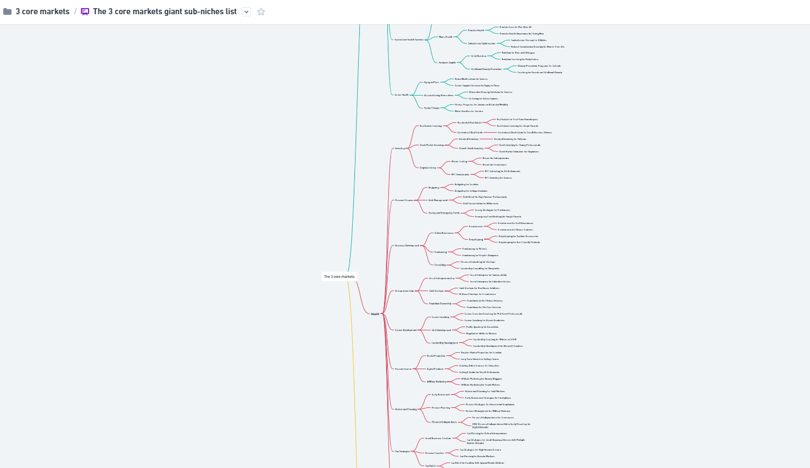

Expander (GPT) 👉
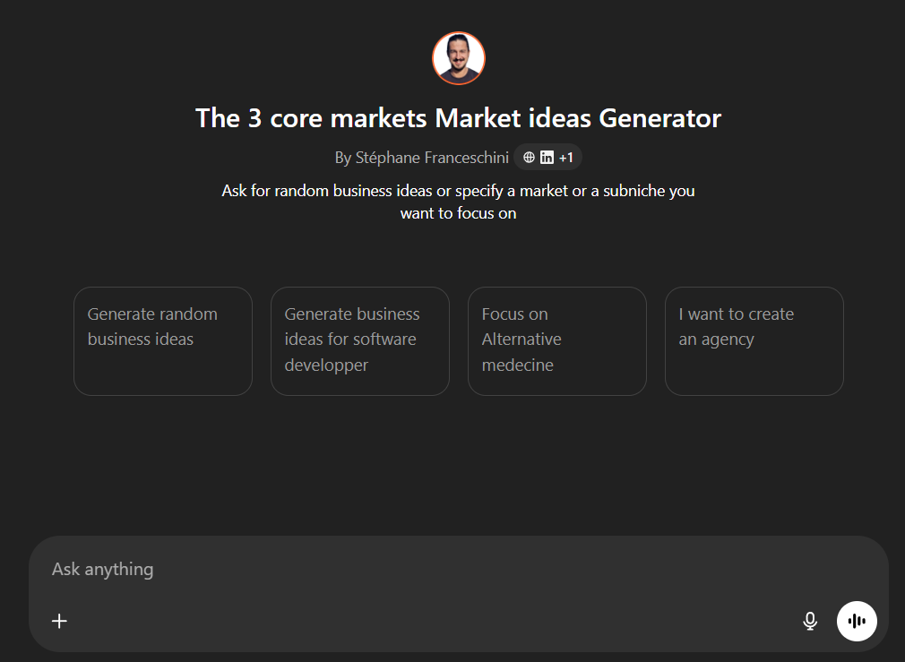

Video Steph to test your idea 👉
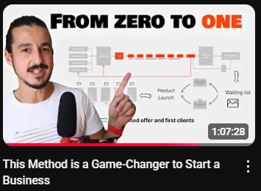

Video Steph how to create unlimited marketing assets that speak directly to your customers' souls 👉

